HemoSim edit doc - N3
HOW TO USE: edit the wording directly (Track Changes if you like). For layout or a figure (size, position, wrong/missing image) write a short instruction in [brackets] right where it applies. Send it back and I apply the wording to the page and the layout notes to the styling, then regenerate. This is a content+notes doc, so it will not look exactly like the web page.

Recognizing shock at the bedside
The last module left us with an uncomfortable fact, that oxygen delivery can be failing while the pressure and the labs still read reassuringly, so recognizing shock has to begin with something faster and more structured than a single number. The quickest honest read on whether oxygen is actually reaching the tissues is the patient's own end-organs, and three of them can be checked at a glance. We call the screen B.U.S.
- B - Brain: Altered mentation, new confusion, agitation or drowsiness?
- U - Urine: Output under 30 mL/hr, or under 0.5 mL/kg/hr?
- S - Skin: Cap refill over 3 s, knees mottled?
Each letter is an end-organ reporting on its own perfusion. The brain shows low delivery as new confusion, agitation, or drowsiness; the kidneys show it as oliguria under about 30 mL/hr; the skin shows it as a capillary refill beyond three seconds or as mottling over the knees. Alongside the three organs sit a few numbers that raise the same alarm, a mean arterial pressure under about 65 mmHg, a lactate over 3 mmol/L, and the tachycardia and tachypnea of a body compensating. No single one is proof, but together they move suspicion fast, and every one of them is a surrogate for the low cardiac output and low delivery of the last module, now made visible.

Why not just follow the pressure?
It is tempting to let the mean arterial pressure stand in for perfusion, but the relationship is treacherous. Blood pressure is not flow; it is flow multiplied by tone, plus the pressure at which the small vessels tend to close:
MAP = (CO × SVR) + PcritPcrit is the critical closing (downstream) pressure of the arterioles. A single MAP can be produced by very different combinations of flow and tone.
Using MAP as a stand-in for cardiac output only works if you assume that SVR and Pcrit hold steady while the pressure moves, and in the ICU that assumption fails three ways at once. The physical exam that might otherwise ground you is unhelpful, because anuria, a warming blanket, and sedation each have non-perfusion explanations. The patient's own physiology has already deviated from normal, so SVR and Pcrit are not where you would guess. And our interventions, the pressors, the fluids, the positive-pressure ventilation, push those very terms further from baseline. A comfortable MAP can therefore sit on top of a circulation that is barely delivering, propped up by clamped-down tone while flow quietly fails.
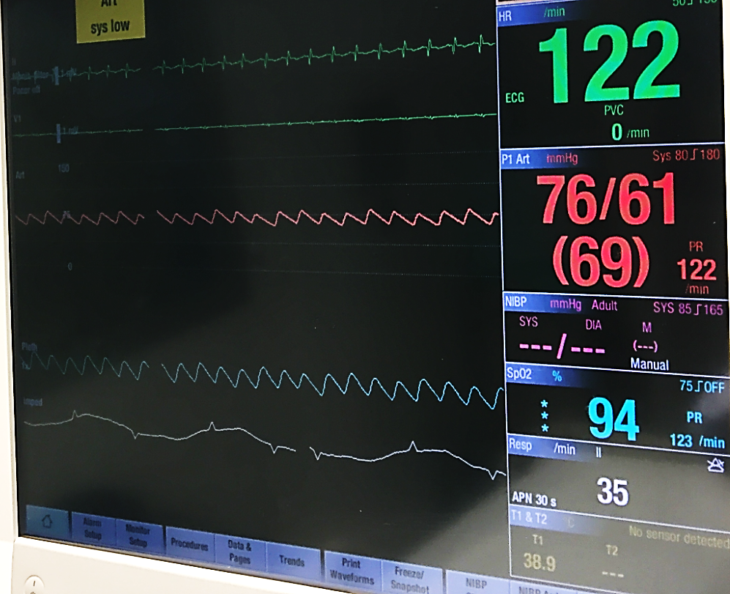
A real ICU monitor: heart rate 122, arterial pressure 76/61 (mean 69), SpO2 94. The numbers look survivable, yet this is exactly the picture that can sit on top of failing oxygen delivery.Source: Assessing Shock deck, slide 5. Attribution to confirm.
[Layout note: figure shown small here; on the web it is capped at ~520px wide. Say if you want it smaller/larger, moved, cropped, or replaced.]

Corroborating the screen: the skin as a window
Capillary refill time is far more informative than its simplicity suggests. Done to the standard used in the landmark trials, you press a transparent glass slide firmly against the distal phalanx of a finger on the hand without the arterial line, hold it for a full ten seconds, release, and start a stopwatch; return of color beyond three seconds is abnormal. That cutoff is not arbitrary. When skin blood flow is mapped against refill time it falls in a near-exponential decay whose inflection sits right around three seconds, so the threshold marks a genuine physiologic cliff rather than a convention. And because the skin is the first vascular bed the body sacrifices under sympathetic drive, refill tracks systemic flow and even splanchnic organ perfusion, and it moves fast: in survivors it normalizes within two to six hours of resuscitation while lactate is still drifting down over a day.
The trial evidence is what elevated the sign. In ANDROMEDA-SHOCK, resuscitating septic shock to a normal capillary refill produced less organ dysfunction at 72 hours and a strong trend toward lower 28-day mortality (34.9 versus 43.4 percent) than resuscitating to lactate. A Bayesian reanalysis put the probability that the refill strategy is superior above 90 percent, and a post hoc look suggested the lactate arm was actually harmed by chasing a number that lags perfusion, driving unnecessary fluid and pressors into patients whose skin was already warm. Its 2025 successor built refill time into a personalized algorithm and again came out ahead, with less fluid given and organ support withdrawn sooner. For a sign you read with your eyes and a glass slide, that is remarkable validation.
Mottling is the second skin window. The violaceous, reticular discoloration that appears over the kneecap is graded 0 to 5 by how far it climbs the leg, from none, to a patch over the patella, out to spread beyond the upper thigh. It is highly reproducible between observers and tracks short-term mortality closely, and crucially it does so independently of vasopressor dose, so mottling that persists on a rising pressor should not be explained away. Physiologically it is the visible print of a collapsing microcirculation: patchy shutdown of nutritive skin flow, regional endothelial dysfunction, and redistribution of blood away from the periphery toward the vital organs.
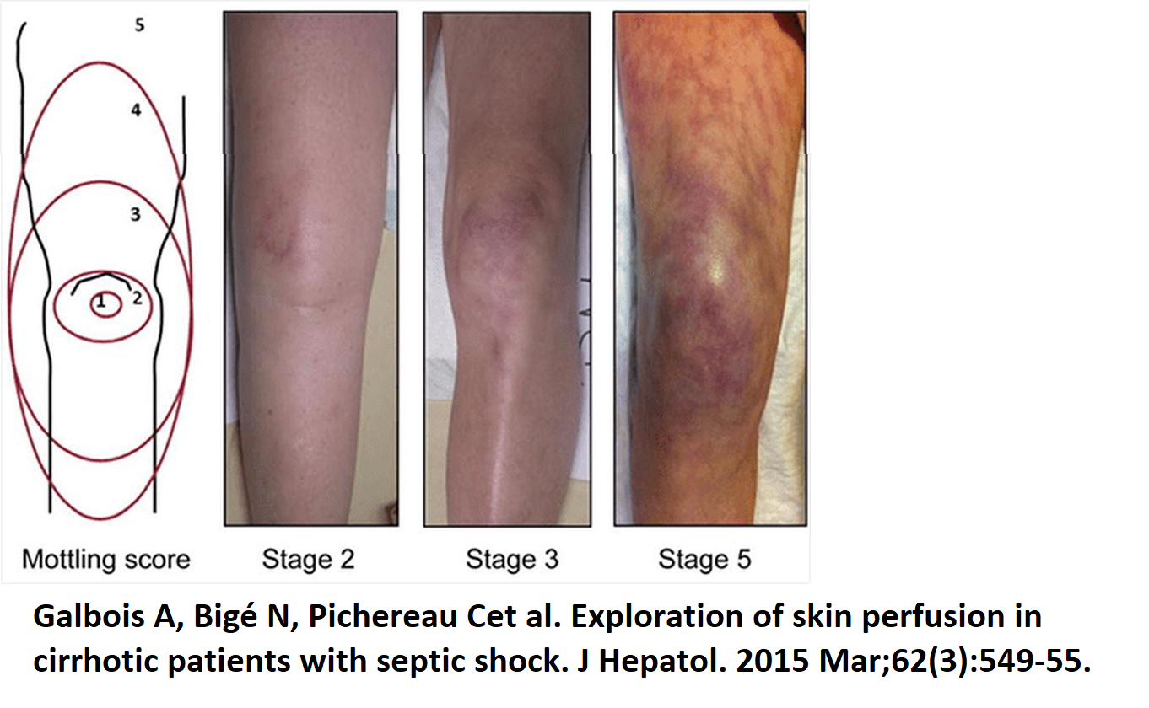
The mottling score, graded 0 to 5 by how far violaceous discoloration extends up from the patella. More extensive mottling predicts higher mortality, even after adjusting for vasopressor dose.Source: Hemodynamics module (v2022), slide 107 (Galbois et al. J Hepatol. 2015;62:549-55). Attribution to confirm.
[Layout note: figure shown small here; on the web it is capped at ~520px wide. Say if you want it smaller/larger, moved, cropped, or replaced.]

Reading the metabolism when a line is in
When a central line is in, three numbers let you interrogate the tissues more directly, and each answers a different question. Lactate over about 2 mmol/L flags that cells are leaning on anaerobic glycolysis, but it is subtler than a simple hypoxia meter: the lactate ion is not itself the acid (the reaction that makes it actually consumes two protons), and it doubles as a redox buffer and a stress signal, so it is best read as a trend rather than a verdict. Central venous oxygen saturation reports the balance of delivery and consumption. From the Fick relationship it approximates the fraction of delivered oxygen left over after the tissues extract what they need:
ScvO2 ≈ 1 − O2ERNormal is roughly 70 to 75 percent, with tissues extracting about a quarter of what is delivered. A low value means they are extracting harder to defend consumption against failing flow.
A low ScvO2 therefore points to a flow-limited state, cardiogenic or hypovolemic, that should respond to more output. A normal or high value in a clearly sick patient is more ominous, because it can mean oxygen is being delivered but not extracted, the microcirculatory shunting and cellular dysoxia of sepsis. The venous-to-arterial CO2 gap completes the set: above about 6 mmHg it signals that flow is too slow to wash CO2 out of the tissues, and because CO2 is highly diffusible it responds faster than lactate. De Backer's framework reads the three together rather than singly, and that is the honest way to use them, since microcirculatory dysfunction can decouple any one from the true state. They corroborate; they do not adjudicate.

Filling as a discriminator: right atrial pressure
Once B.U.S. and these markers say a patient is in shock and the pressure will not tell you why, the next step is to take apart what makes that pressure: tone, filling, and flow. When the etiology is unclear or the shock is worsening, an advanced look measures the three levers directly, and their pattern begins to name the type.
Shock type | CO | RAP | SVR
Cardiogenic (LV) | ↓ | ↑ | ↑
Obstructive (RV) | ↓ | ↑ | ↑
Distributive | ↔/↑ | ↓ | ↓
Hypovolemic | ↓ | ↓ | ↑
Of the three levers, filling pressure, the right atrial pressure, is the most reachable at the bedside, through a central line, a Swan-Ganz catheter, the jugular venous pulse on exam, or the collapsibility of the inferior vena cava on echo. A single static reading deserves the caution it gets: as the teaching analogy goes, a lone CVP is like a PCO2 with no pH, uninterpretable without a goal and a context. But used deliberately it discriminates. A high RAP, roughly above 10 mmHg, fits a heart that cannot accept more volume and points toward cardiogenic or obstructive shock; a low RAP, under about 5, fits an empty or dilated circulation, hypovolemic or distributive. It was on exactly this logic that the Rivers protocol assumed early septic patients would have a low filling pressure and pushed CVP up toward 8 to 12. The venous-return relationship explains why the same number also predicts what a fluid bolus will do:
MSFP − RAP = CO × RvFlow back to the heart is driven by the gradient between mean systemic filling pressure and right atrial pressure. When a failing ventricle lets RAP climb as fast as filling, the gradient does not widen and output does not move.
[Offshoot / At-the-Bedside link: At the bedside: a low RAP does not license a fluid bolus. A high value does argue that a patient is near the flat top of the cardiac function curve and unlikely to respond to volume, but a low value is closer to a coin flip, the classic Magder observation that many patients with a low CVP gain nothing from fluid. Treat low filling as permission to test volume, ideally with a measured change in output, not as proof of responsiveness. And read every RAP through PEEP, obesity, pulmonary hypertension, and intraabdominal pressure, any of which lifts the number without more blood behind it.]
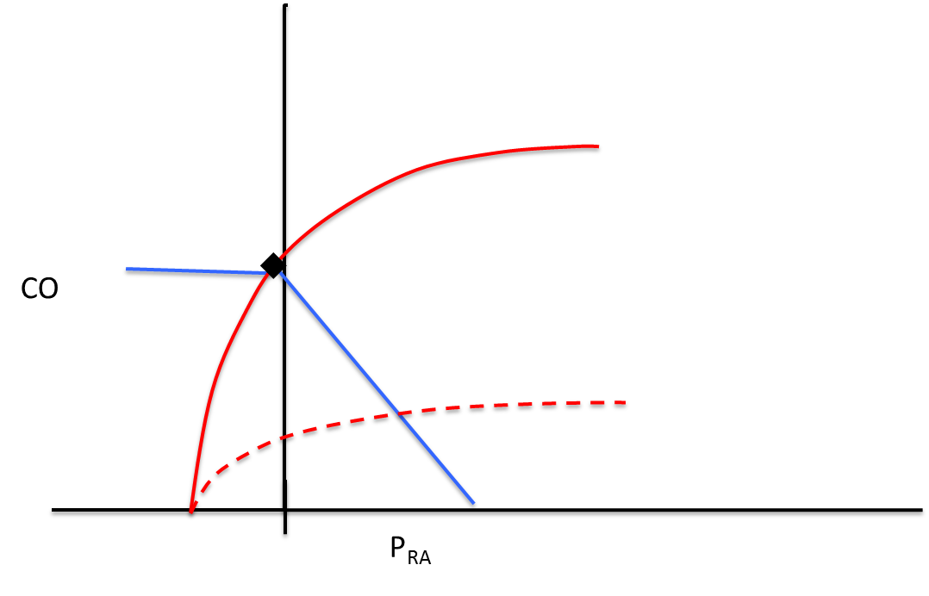
Cardiac output against right atrial pressure. The venous-return line (blue) crosses the cardiac-function curve (red) at the operating point; a depressed, dashed function curve, where RAP rises with filling but output does not, is the signature of cardiogenic shock.Source: Assessing Shock deck, slide 39. Attribution to confirm.
[Layout note: figure shown small here; on the web it is capped at ~520px wide. Say if you want it smaller/larger, moved, cropped, or replaced.]
All of this recognizes shock and takes a first guess at its type, but it does not yet explain the machinery, why raising filling rescues one patient and does nothing for another, why tone and flow trade off the way they do.
That machinery is the circulation seen whole, a single closed loop broken into a few interfaces where flow can fail, and it is where the next module begins and where the physiology finally connects to the shock-type grid.

References
[Citations are editable: correct authors, years, journals, or page ranges directly, add a missing source, or flag one you want checked. These mirror the reference list at the foot of the web page.]
- Hernández G, Ospina-Tascón GA, Damiani LP, et al. Effect of a resuscitation strategy targeting peripheral perfusion status vs serum lactate levels on 28-day mortality among patients with septic shock (ANDROMEDA-SHOCK). JAMA. 2019;321(7):654-664.
- Hernández G, Ospina-Tascón GA, Kattan E, et al. Personalized hemodynamic resuscitation targeting capillary refill time in early septic shock (ANDROMEDA-SHOCK-2). JAMA. 2025;334(22):1988-1999.
- Zampieri FG, Damiani LP, Bakker J, et al. Effects of a resuscitation strategy targeting peripheral perfusion status versus serum lactate levels among patients with septic shock: a Bayesian reanalysis of the ANDROMEDA-SHOCK trial. Am J Respir Crit Care Med. 2020;201(4):423-429.
- Kattan E, Hernández G, Ospina-Tascón GA, et al. A lactate-targeted resuscitation strategy may be associated with higher mortality in patients with septic shock and normal capillary refill time: a post hoc analysis of the ANDROMEDA-SHOCK study. Ann Intensive Care. 2020;10(1):114.
- Jacquet-Lagrèze M, Pernollet A, Kattan E, et al. Prognostic value of capillary refill time in adult patients: a systematic review with meta-analysis. Crit Care. 2023;27:473.
- Morin A, Missri L, Urbina T, et al. Relationship between skin microvascular blood flow and capillary refill time in critically ill patients. Crit Care. 2025;29:57.
- Hernández G, Luengo C, Bruhn A, et al. When to stop septic shock resuscitation: clues from a dynamic perfusion monitoring. Ann Intensive Care. 2014;4:30.
- Ait-Oufella H, Lemoinne S, Boelle PY, et al. Mottling score predicts survival in septic shock. Intensive Care Med. 2011;37(5):801-807.
- Dumas G, Lavillegrand JR, Joffre J, et al. Mottling score is a strong predictor of 14-day mortality in septic patients whatever vasopressor doses and other tissue perfusion parameters. Crit Care. 2019;23:211.
- Galbois A, Bigé N, Pichereau C, et al. Exploration of skin perfusion in cirrhotic patients with septic shock. J Hepatol. 2015;62(3):549-555.
- De Backer D. Detailing the cardiovascular profile in shock patients. Crit Care. 2017;21(Suppl 3):311.
- Ospina-Tascón GA, Umaña M, Bermúdez W, et al. Combination of arterial lactate levels and venous-arterial CO2 to arterial-venous O2 content difference ratio as markers of resuscitation in patients with septic shock. Intensive Care Med. 2015;41(5):796-805.
- Bakker J, Coffernils M, Leon M, Gris P, Vincent JL. Blood lactate levels are superior to oxygen-derived variables in predicting outcome in human septic shock. Chest. 1991;99:956-962.
- Magder S. Central venous pressure monitoring. J Intensive Care Med. 2007;22:44-51.
- Rivers E, Nguyen B, Havstad S, et al. Early goal-directed therapy in the treatment of severe sepsis and septic shock. N Engl J Med. 2001;345(19):1368-1377.
Figures imported from the source decks (slide cited on each caption); attribution to confirm before publication.

